The below url is for reference how the html is looking like in production

<https://www.sant-just.com/chatbox/chatbox.html>

1. On initial loading the page is looking like below with a small window and as messages keep coming it grows to certain size. Do change to fix the height of this section. It should not shrink/expand. If message will be more than length of this section then scroll bar should appear

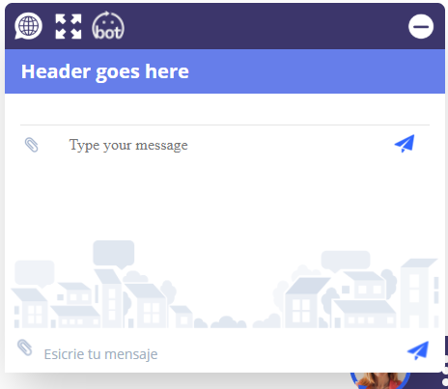

COMMENT : FIXED

1. Remove the encircled section, we don’t need it . this section is coming from bot automatically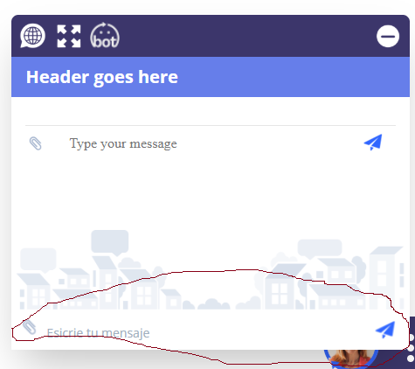

COMMENT : FIXED

1. The background image should be a part of the bot chat box, it should be the background of the bot chat box, change it.

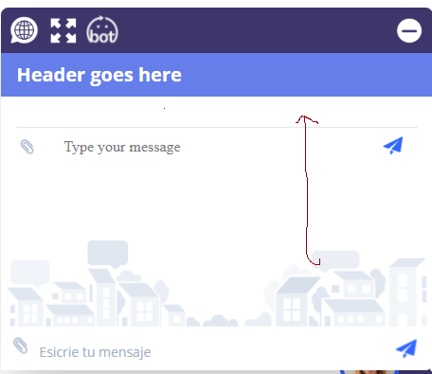

COMMENT : FIXED

1. Adjust the scrollbar, now it is at the top. it should be at the bottom of the section always, so that new messages will be visible. I has to move down automatically with the new message.

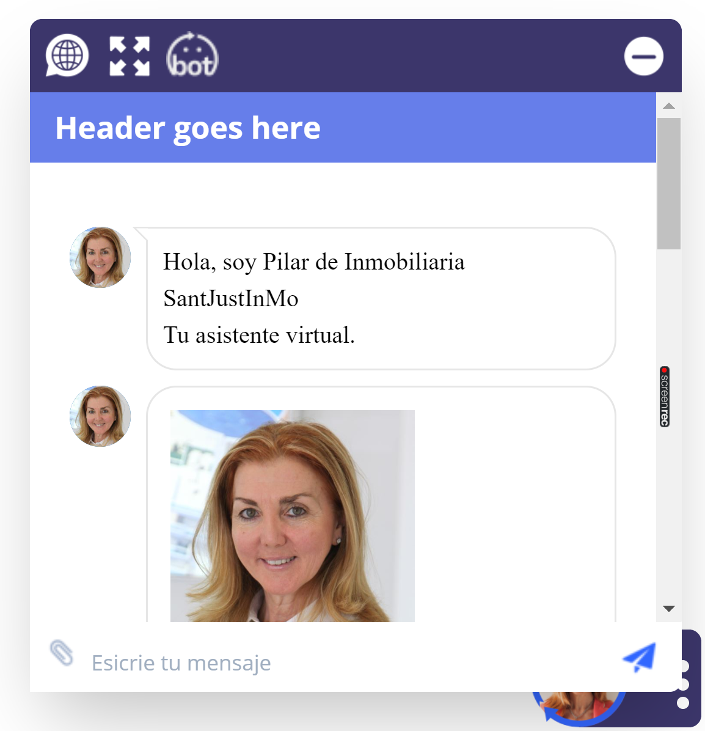

COMMENT : FIXED

1. on web btn click it is opening the language list as below, on any language option click this list should close

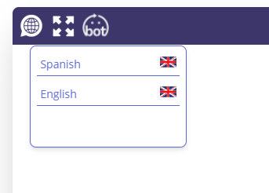

Language selector not working on mobile device: **Iphone and Ipad.**

COMMENT : FIXED

1. The mobile view of chat bot section is not fitting to screen properly. Some info from left side is missing. please do the required css changes fr this

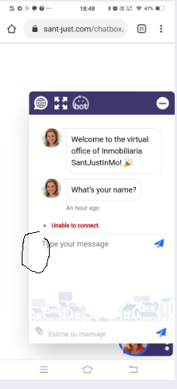

COMMENT : FIXED

1. (new) add a wait loader to this section, that will run till the bot is not starting to respond when someone is changing language. When u will click the language after sometime that language bot starts sending message. So want a wait loader to run till the time next msg is not coming from bot after clicking any language.

When page loads we show something like this:



COMMENT : NOT FIXED, PLEASE GIMME THE GIF SO THAT I CAN MAKE IT MORE ATTRACTIVE

1. There is an extra white section. Delete this.

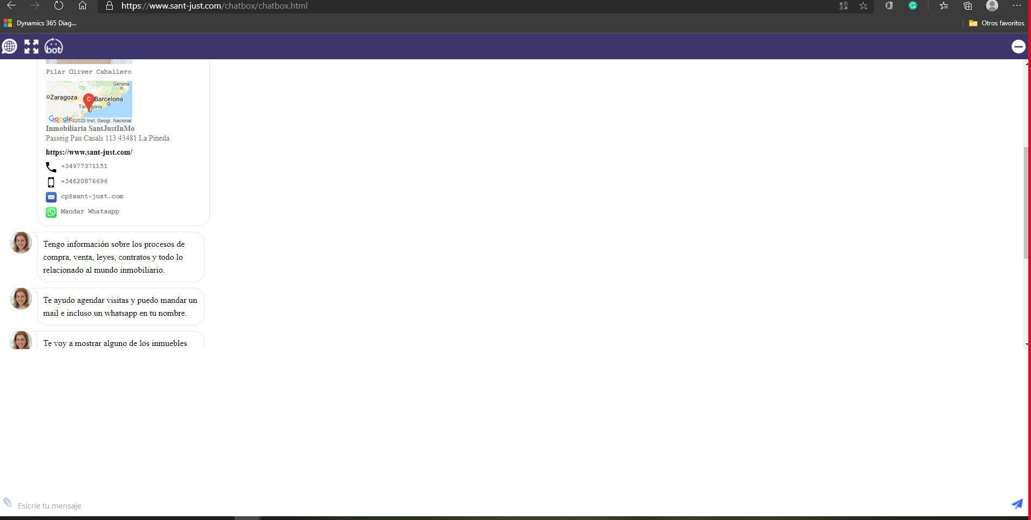

COMMENT : FIXED

1. First time full screen issue

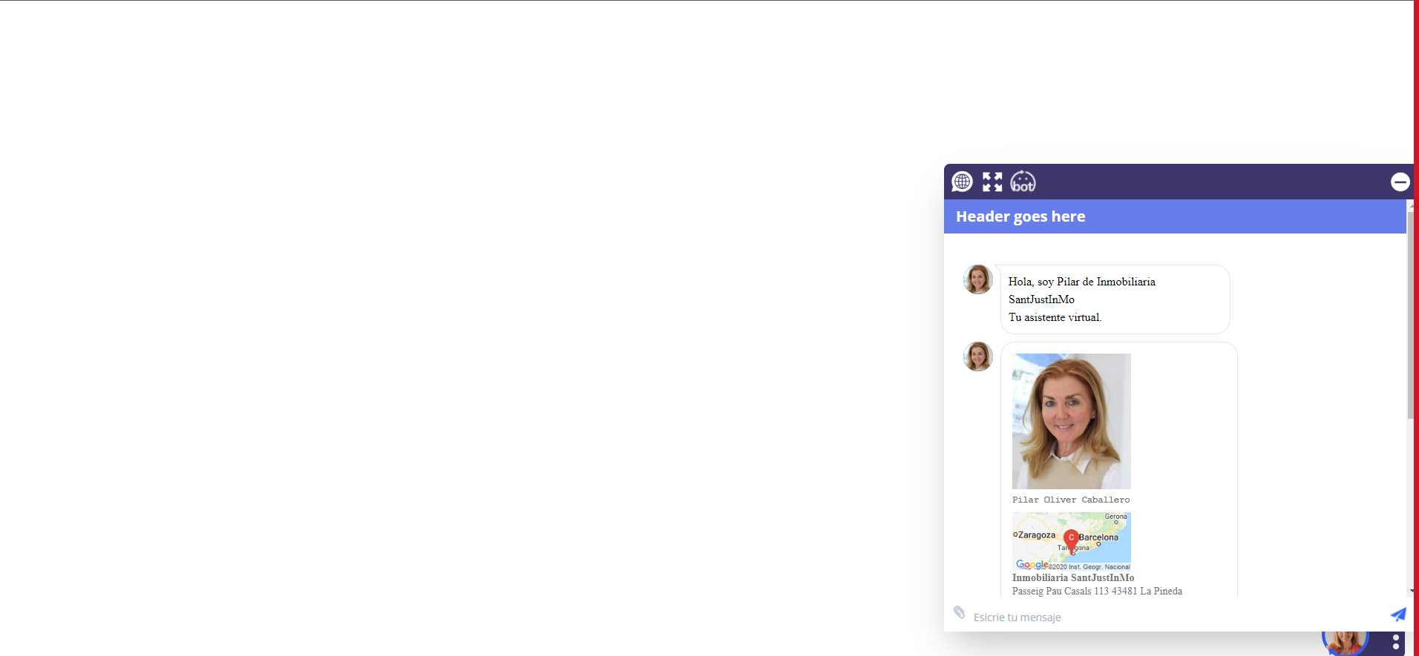

Open full screen

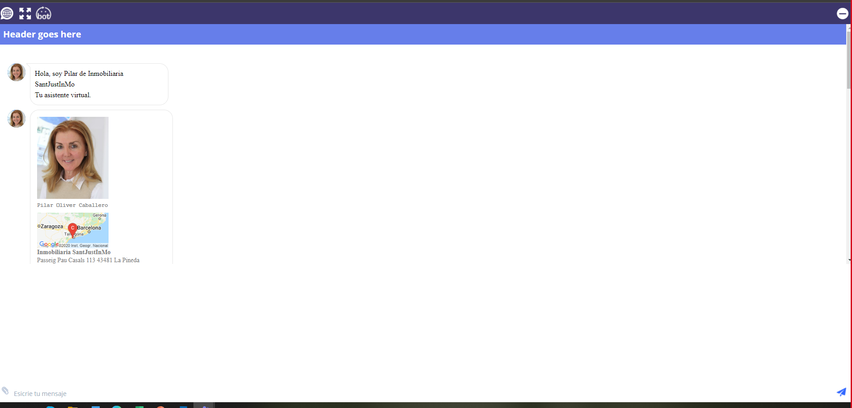

Ok, now go back to normal screen hitting the X.

Then screen will stay on upper left sided like this:

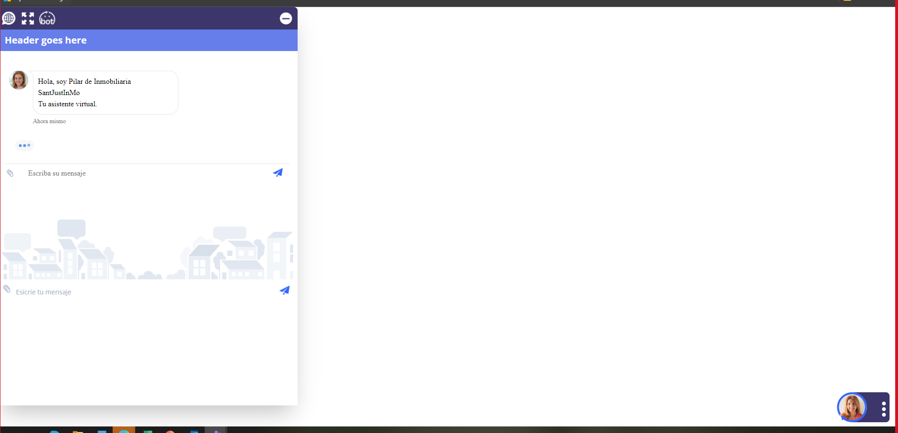

The second time it will open and close correctly.

COMMENT : FIXED

1. Ipad design not ok

It is to stretchy for both horizontal and vertical position. Make it wider please.

